How to refresh Perf DB “Acm01vegasjetty”

Author:Andrew Jia

First version:2017-11-22

# 1.Get latest “ClearProductionData.sql” and raise a ticket to DBA

## Ticket

Ticket detail may like this--

Reason: Annual refresh perf test DB from live customer data.   
Source DB Server: DBANET01vs  
DB name: chicagoparkdistrict  
  
Target DB server: DBANET12VS.active.tan\DBANET12VS  
DB name: ACM01VegasJetty  
  
Steps:  
1. Backup source DB "chicagoparkdistrict"  
2. Restore to target DB "ACM01VegasJetty"  
3. Run ClearProductionData.sql for restored DB - ACM01VegasJetty  
4. I'll run SQLs to insert/modify data to make it for performance testing.   
5. Then backup target DB to "\\wsdbbckup01\AnetPerfBackup " with keywords "20171122CPDBackup", we need restore from this DB in later time, to avoid test DB become too large.

## Latest “ClearProductionData.sql”

1. Access this URL- <https://gitlab.dev.activenetwork.com/ActiveNet> with your account
2. Choose project “db-schema”
3. Find “ClearProductionData.sql” and save it on local folder
4. Replace things like "delete from dbo.XXXXX;" with the following in the sql:

USE [ACM01vegasJetty]

GO

ALTER TABLE [dbo].[RECEIPTPAYMENTSPENDING]

DROP CONSTRAINT [FK_RECEIPTPAYMENTSPENDING__ICVERIFYLOG_ID]

truncate table dbo.XXXXX;

ALTER TABLE [dbo].[RECEIPTPAYMENTSPENDING] WITH NOCHECK ADD CONSTRAINT [FK_RECEIPTPAYMENTSPENDING__ICVERIFYLOG_ID] FOREIGN KEY([ICVERIFYLOG_ID])

REFERENCES [dbo].[ICVERIFYLOG] ([ICVERIFYLOG_ID])

GO

ALTER TABLE [dbo].[RECEIPTPAYMENTSPENDING]

CHECK CONSTRAINT [FK_RECEIPTPAYMENTSPENDING__ICVERIFYLOG_ID]

GO

1. Add addition sqls below in the end of “ClearProductionData.sql”—

USE [ACM01vegasJetty]

GO

CREATE USER [TAN\AN_Perf] FOR LOGIN [TAN\AN_Perf]

GO

USE [ACM01vegasJetty]

GO

ALTER ROLE [db_datareader] ADD MEMBER [TAN\AN_Perf]

GO

USE [ACM01vegasJetty]

GO

ALTER ROLE [db_datawriter] ADD MEMBER [TAN\AN_Perf]

GO

USE [ACM01vegasJetty]

GO

ALTER ROLE [db_ddladmin] ADD MEMBER [TAN\AN_Perf]

GO

Note:you can find these sqls in file “1_Add Perf Account.sql”

# 2. Log on DB with SSMS and run “2_AMS_loadTest.sql”

# 3. Then run “3_AllowLoginAsCustomer_ID.sql”

# 4.Modify “4_ActivitiesPrep.sql” and run it on DB

## (1) Access page <https://apm.activecommunities.com/chicagoparkdistrict>

## (2) Activities-Seasons to choose a season name

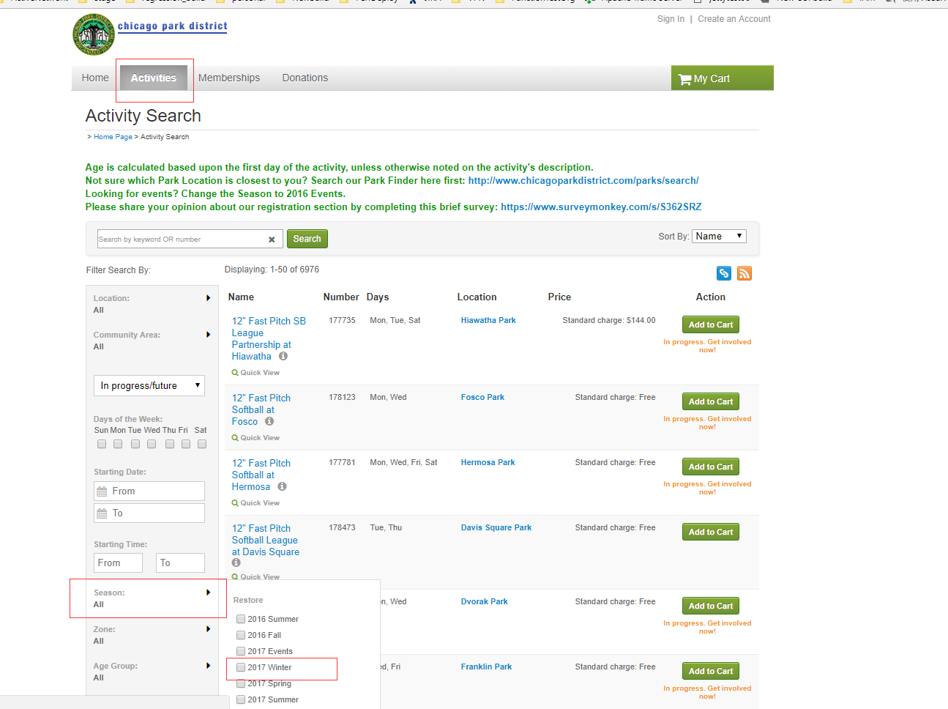

## (3) Run “select * from seasons where season_name = 'season name you find previous'” on perf DB to find out the season id

## (4) Change season id in “4_ActivitiesPrep.sql”

## (5) Run this sql file on perf DB

Note: parameter “number_open”

This parameter is the number enroll for each activity,make sure it is >0 for perf using

# 5.Stop all service to avoid issues and then run “5_CreateAccount.sql”

Before running the sql, MUST **Stop all service to avoid issues.**

Take a look at the sql file and if no need to change the amount of customers , run the sql.

Note:Suggest to do this on remote PC

# 6. Run “6_CustomerQuestion_SetAsNotRequired.sql” on perf DB

# 7. SetWaiverAsNotRequired

## (1) update DB schema by deploy new build to perf org

## (2) access AUI page,



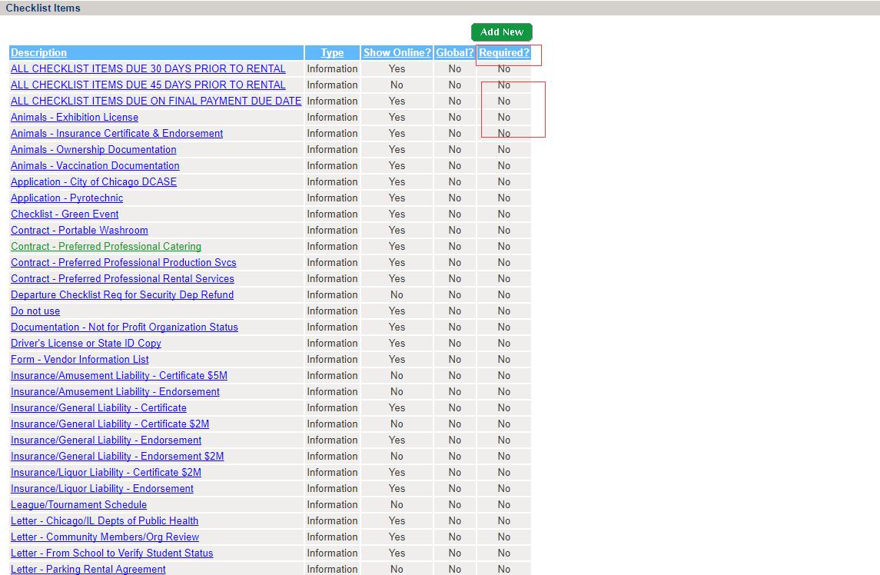

Make sure value of “Required?” column is No

How to change it?

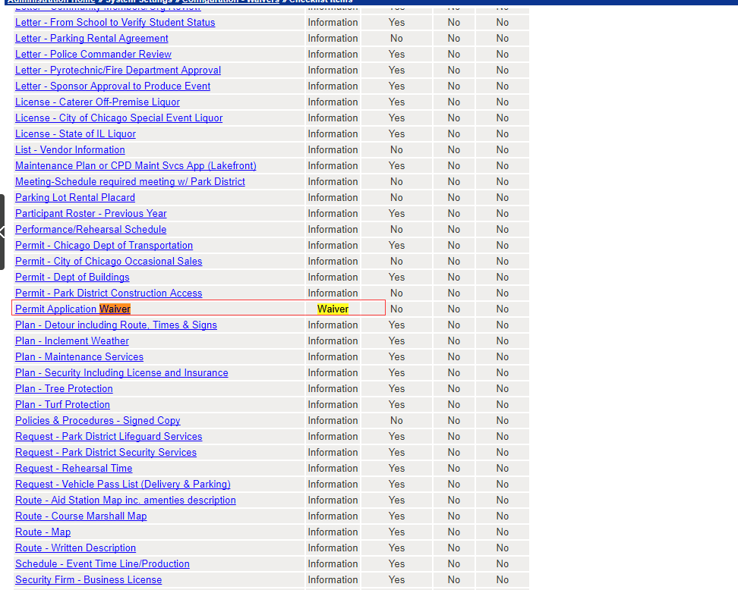

Choose one ,then click its name

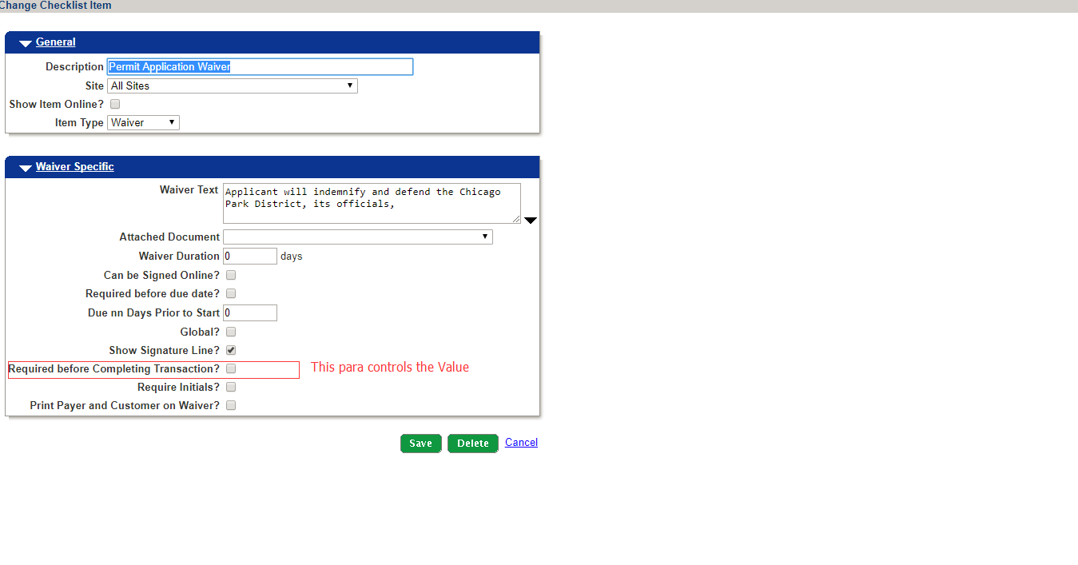

Unselect this parameter

# 8.Change SeasonID in the sql file and run “8_GetNewActivityIdList.sql”

SeasonID can be found in previous step(Step 4)

Then export all data to a csv file with name “ActivityNumbers.csv” on local hardware.

# 9. Run 9_CreateFamilyMember.sql

# 10. Run 10_CreateFamily.sql

# 11. Run 11_AddFamilyMember.sql

# 12. Run 12_EnableCacheContorl.sql

# 13. Run 13_ChangeCacheMode.sql

ChangeCacheMode if necessary

# 14. 14_ModifyAMSSettingfromAUI

On AUI Page, Financial Settings->Configutarion,Change AMS settings like below:

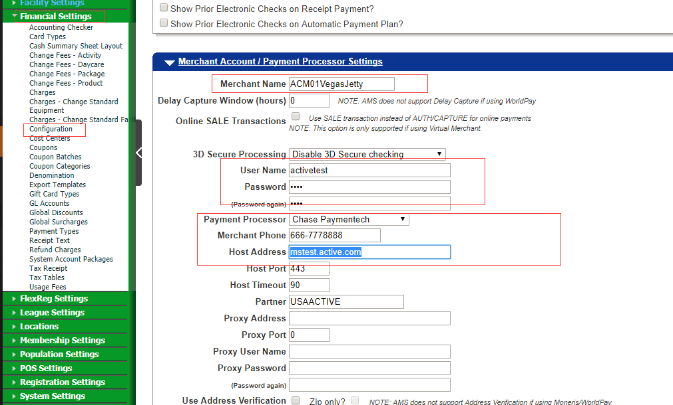

# 15. Insert New cart address

# 16. Update customers password

On CUI page,create a new account with password “safari@1”

Search this customer on DB and get the password_ID,then update all insert users’ password_ID with this ID

use acm01vegasjetty

update customers set is_enc_password = 0 where customer_id between 1000001 and 3999999

update customers set password_id = (select password_id from customers where firstname = 'andrew' and lastname = 'jia') where customer_id between 1000001 and 3999999

# 17. Back up new DB

# 18. Update USED value

# Note:

INC ticket: INC2434983